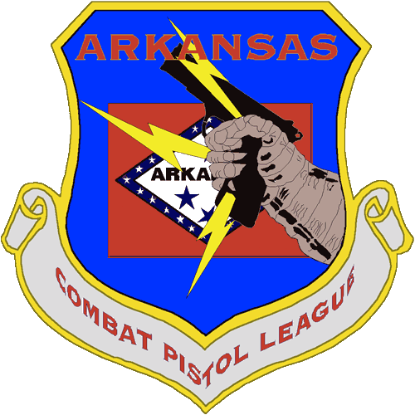
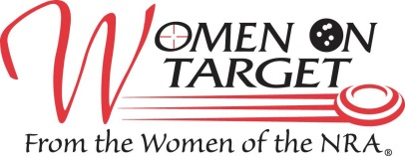
The Ladies of Arkansas Combat Pistol League Proudly announce the 3rd Annual
NRA Women on Target Instructional Shooting Clinic
June 18, 2016
Where: Arkansas Combat Pistol League
Luther Owens Muzzleloading Range, 1300 Chafin Road, Berryville, AR
From Hwy. 62, take Hwy. 221/21 N; Turn right on College St. (Please drive carefully, this is a residential area.)
Turn left on Chafin Rd.; the range is on the left

When: Saturday, June 18, 2016, sign-in begins at 8:30 am

Agenda: 8:30 – 9:00 am Sign-in and registration
9:00 – 9:30 am Welcome
9:30 – 9:45 am Safety Instructions (NRA Certified Instructors)
9:45 – 12:00 noon Range Instruction (Pistols in morning)
12:00 – 1:00 pm Lunch
1:00 – 2:30 pm Shotgun, Rifle, and Pistol at the ranges of your choice

Cost: $15.00. Cost includes lunch, use of firearms, targets, eye and ear protection and ammunition. Clinic is rain or shine. Free goody bags to the first 120 paid registrants.
T-shirts: $15 extra.

Contact: Lisa May (501) 681-8458 Allison Launius (252) 626-4690 Ronda Ray (870) 350-2411
Email: lisam@madisoncounty.net

Preregistration is preferred but not required. We can only take the first 120 paid registrants. Send completed registration form and payment to:
Arkansas Combat Pistol League
Attn: NRA Women on Target Clinic
1397 Underwood Lane
Berryville, AR 72616

NRA Women on Target Clinic Registration Form
Name: _______________________________________________
Address: _____________________________________________
_____________________________________________________
Phone: _______________________________________________
Email: _______________________________________________
T-shirts: $15 extra. ______Small ______Medium _____Large ______X Large _____XX Large

WAIVER, RELEASE AND COVENANT NOT TO SUE
Berryville, Arkansas

IN CONSIDERATION OF ARKANSAS COMBAT PISTOL LEAGUE, ITS OFFICERS AND MEMBERS THEREOF AND ALL THOSE PERSONS AND FIRMS WHO MAY BE LIABLE ON THEIR BEHALF, PERMITTING ME to attend and participate in, or to be a spectator of their NRA Women on Target Clinic, I on my own behalf and on behalf of my heirs, representatives, administrators and assigns, hereby waive and release any and all claims, demands, causes of action, suits and rights, I or anyone on my behalf, might have against those persons and firms named above for any personal injury (including death), loss and damage to my property which I (or anyone claiming by or through me) may have against any and all of those persons, leagues and firms named above as a result of my participation in or being a spectator of their NRA Women on Target clinic.
Further, I agree that I will not, or will anyone acting on my behalf claiming by or through me, bring or maintain any suit in any court to assert any claim against those persons, leagues and firms named above for any claim that I might have arising out of my participation in or being a spectator of their NRA Women on Target clinic.
I UNDERSTAND THAT PARTICIPATION IN, OR BEING A SPECTATOR, AT SHOOTING MATCHES, SHOOTING CONTESTS, AND FIREARMS DEMONSTRATIONS AS WELL AS RANGE LOCATED NON-SHOOTING ACTIVITIES INVOLVES A HAZARD AND RISK OF PERSONAL INJURY OR DEATH AND LOSS OR DAMAGE TO PERSONAL PROPERTY, AND HEREBY VOLUNTARILY ASSUME THESE RISKS.
I have read and understand the foregoing provisions of this WAIVER, RELEASE AND COVENANT NOT TO SUE and I have executed this instrument voluntarily on this date.
I also recognize that the hosts of this event are not obliged to permit me to participate in this event and that the host may discontinue my participation and ask me to leave the property at any time; and if so requested to leave I will do so in a timely and cooperative manner.

__________________________________ _______________________________________
DATE Participant or spectator, FULL NAME-Print

__________________________________ _______________________________________
Witness Signature of participant, spectator or guardian

